**Removing Specific Disk Space issues**

* Settings
* Preferences
* Select Disk Options
* 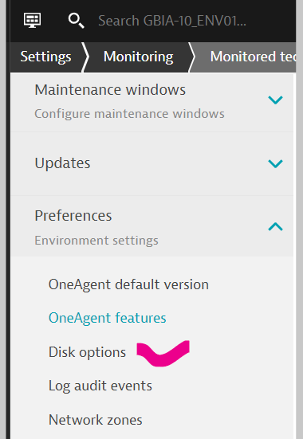
* Click on Add Item
* 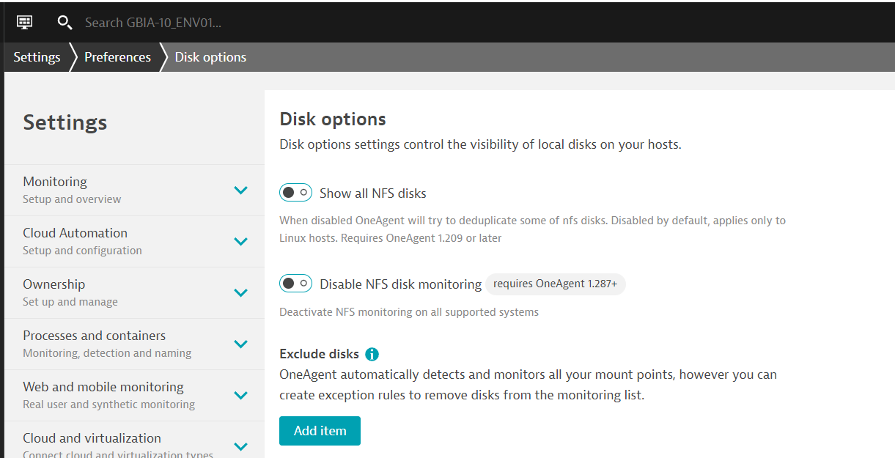
* Select OS and Disk/Mountpoint you want to exclude
* Save the changes

